
SHIRE HIGHLANDS EDUCATION DIVISION
2026 MALAWI SCHOOL CERTIFICATE OF EDUCATION MOCK
EXAMINATION

TECHNICAL DRAWING
PAPER I (100 marks) Subject Number: M201/I
Monday, 9 March Time Allowed: 2 h 40 min
1:30-4:10 pm
GEOMETRICAL AND ORTHOGRAPHIC DRAWING
Note to invigilator
The working time for this paper is 2 hours and 30 minutes. An additional time of ten minutes is allowed at the beginning of the examination for reading through the paper.
Note to the candidates
- This paper contains 7 printed pages with sections A and B. Please check.
- Write your name on the bottom right-hand-corner of your drawing sheet
- All construction lines must be shown clearly, and must not be erased.
- All dimensions are in millimeters unless otherwise stated.
- Unless stated in the question, strictly geometrical methods must be used but lines which are parallel, perpendicular, or inclined at angles of 30⁰, 45⁰ or 60⁰ to other lines may be drawn without showing construction lines.
- Accuracy and good draughtsman ship are essential. You should use both sides of the drawing paper.
- Answer five questions. Not more than three questions may be taken from one section of the paper. The number of each question taken must be indicated clearly.
- All questions carry equal marks

SECTION A- PLANE GEOMETRY
- A point moves in a plane in such a way that its eccentricity is 3:4. Given that the distance between a fixed point and a fixed line is 35 mm:
- Plot the curve (12 marks)
- Name the curve (1 mark)
- Construct a tangent to the curve at any point ‘P’. (7 marks)

- Figure 1 shows the view of a CAM. Construct, full size, the given view. Clearly show the methods of construction for all the centres of radii, the points of tangency and elliptical curve (20 marks)
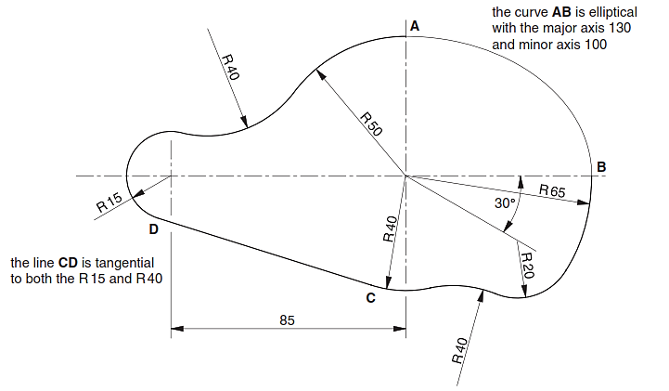 Figure 1

- Figure 2 shows one position of a simple mechanism. Link OB rotates about O. link ABC moves so that A can only travel along the axis XX. Link CP always remains vertical.

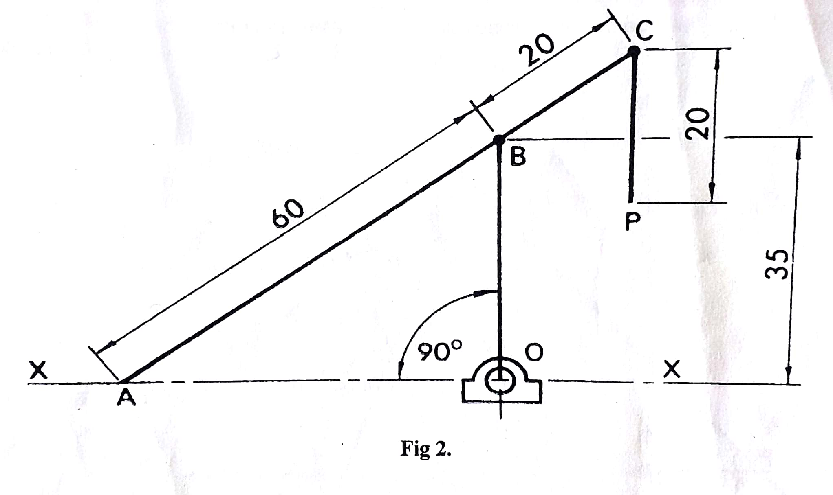
Figure 2 Plot full size, the path of P as B makes one revolution (20 marks)

- a. Construct a diagonal scale of 25 mm to tepresent 1 m to read in metres and
centimetres up to 5 metres
- Use the scale constructed in (a) to construct a quadrilateral PQRS with PQ = 3.72 m, QR = 2.53 m, PS = 3.17 m, angle PQR = 120⁰ and angle SPQ = 90⁰ (20 marks)

SECTION B- SOLID GEOMETRY
- Figure 3 shows two views of a block drawn in first angle orthographic projection. Draw the block in Isometric projection with corner X as the lowest point. (20 marks)

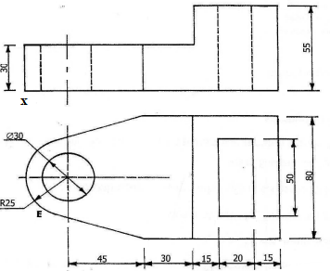

Figure 3

- Figure 4 shows the elevation of a right cone which has a height of 120 mm and a base diameter of 80 mm. The cone is cut by a plane as shown in figure 4.
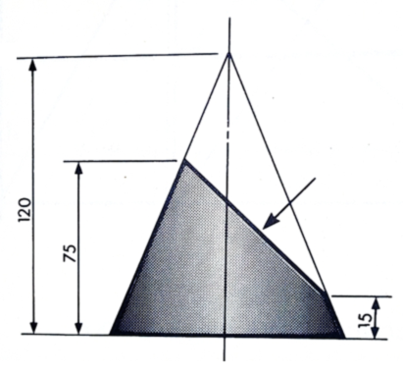
Fig 4
  - Copy the given view (3 marks)
  - Project the true shape of the truncated part (7 marks)
  - Draw the plan (10 marks)

- Figure 5 below shows the plan and elevation of a triangular lamina.

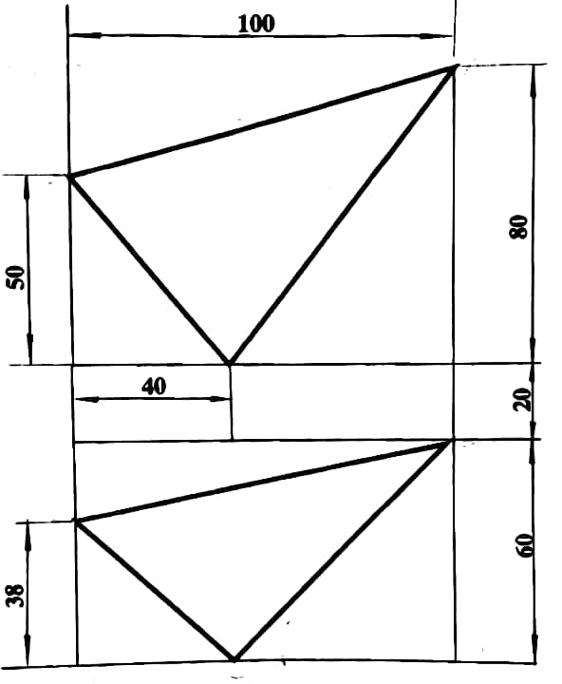
Figure 5
- Copy the given views (6 marks)
- Determine the true shape of the lamina (14 marks)

- Draw one and half convolutions (turns) of a right-hand helical spring 60 mm outside diameter. The spring is made from 10 mm square steel material with a pitch of 56 mm.
(20 marks)
END OF QUESTION PAPER
NB: This paper contains 6 printed pages

